**Homework#5**

Yuhang Peng

**5.6**

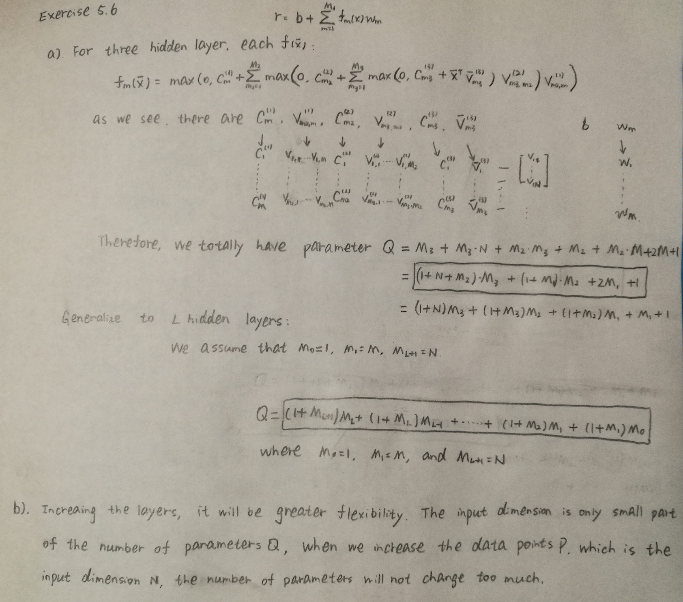

**5.7**

**(a)**

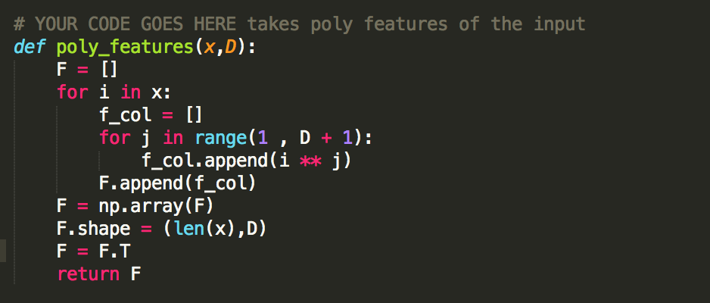

**(b)**

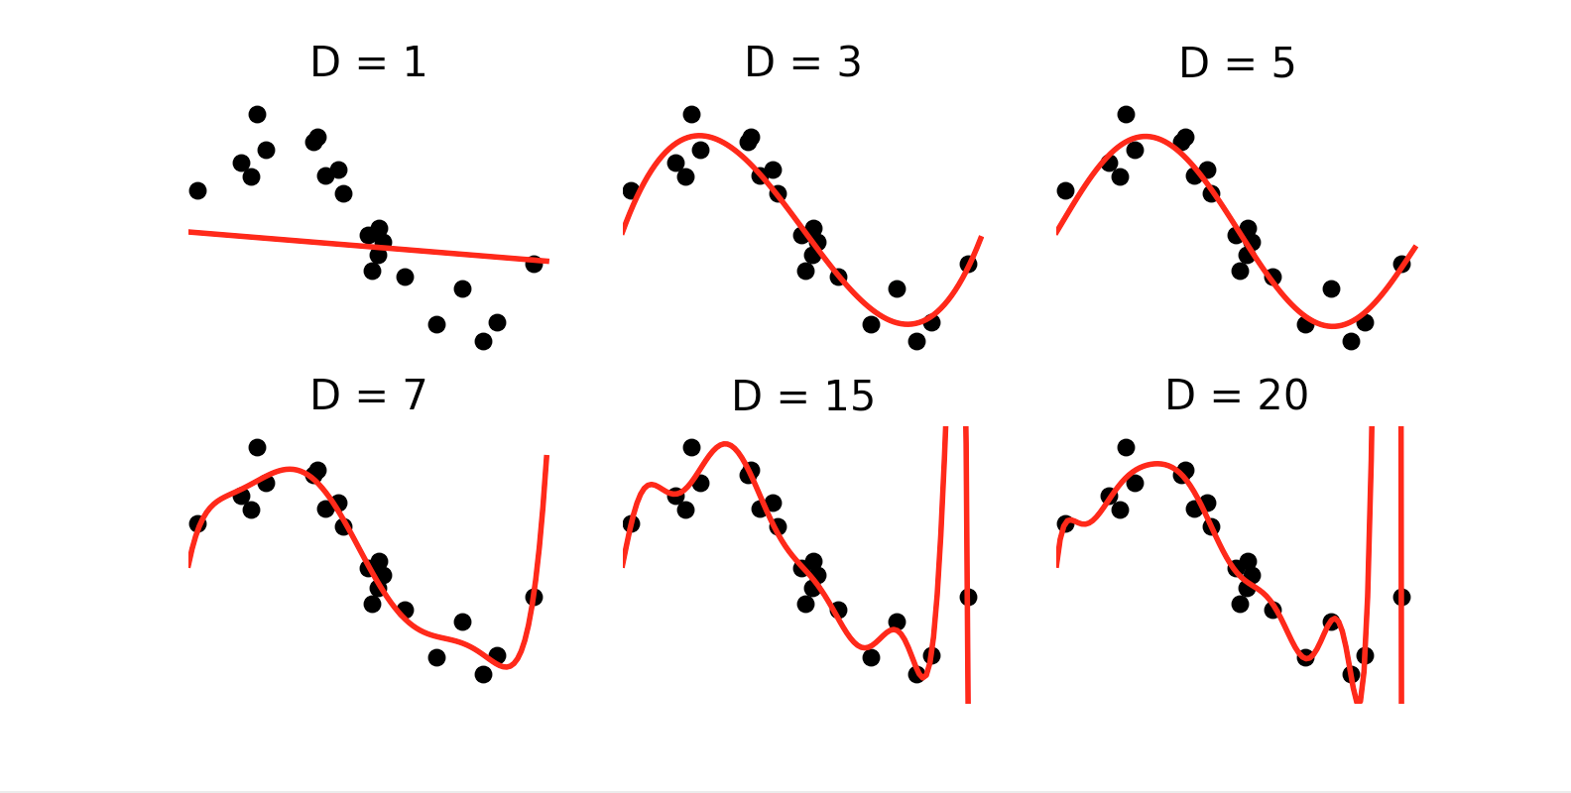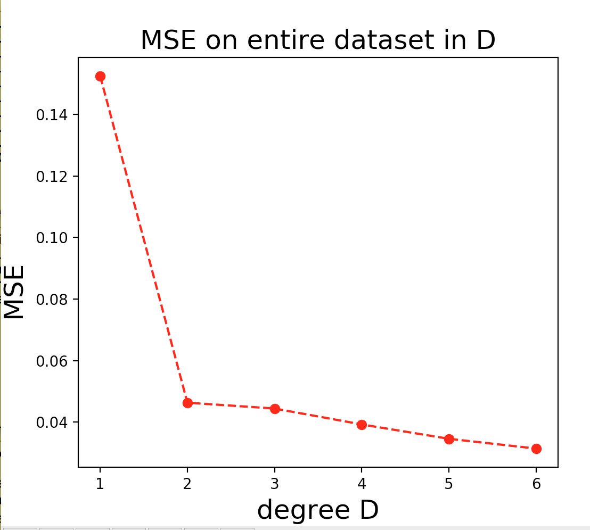

The left figure shows the function we generate by choosing different D, and the right figure shows the mean squared error at each fit to the data set. When we increase the D, the error will decrease, and the figure will become more similar to the original function. However, these data are real data, which means there should have some error, not perfect, when the D is too large, the result will become different, which is called over-fit. We also need to make sure that D is enough, and if D is too small, there will be much errors, and result is not we expect, which is called under-fit. Therefore, we need to choose a suitable D fit for the data set. For this question, the D should be located at 3-5.

**5.9**

**(a)**

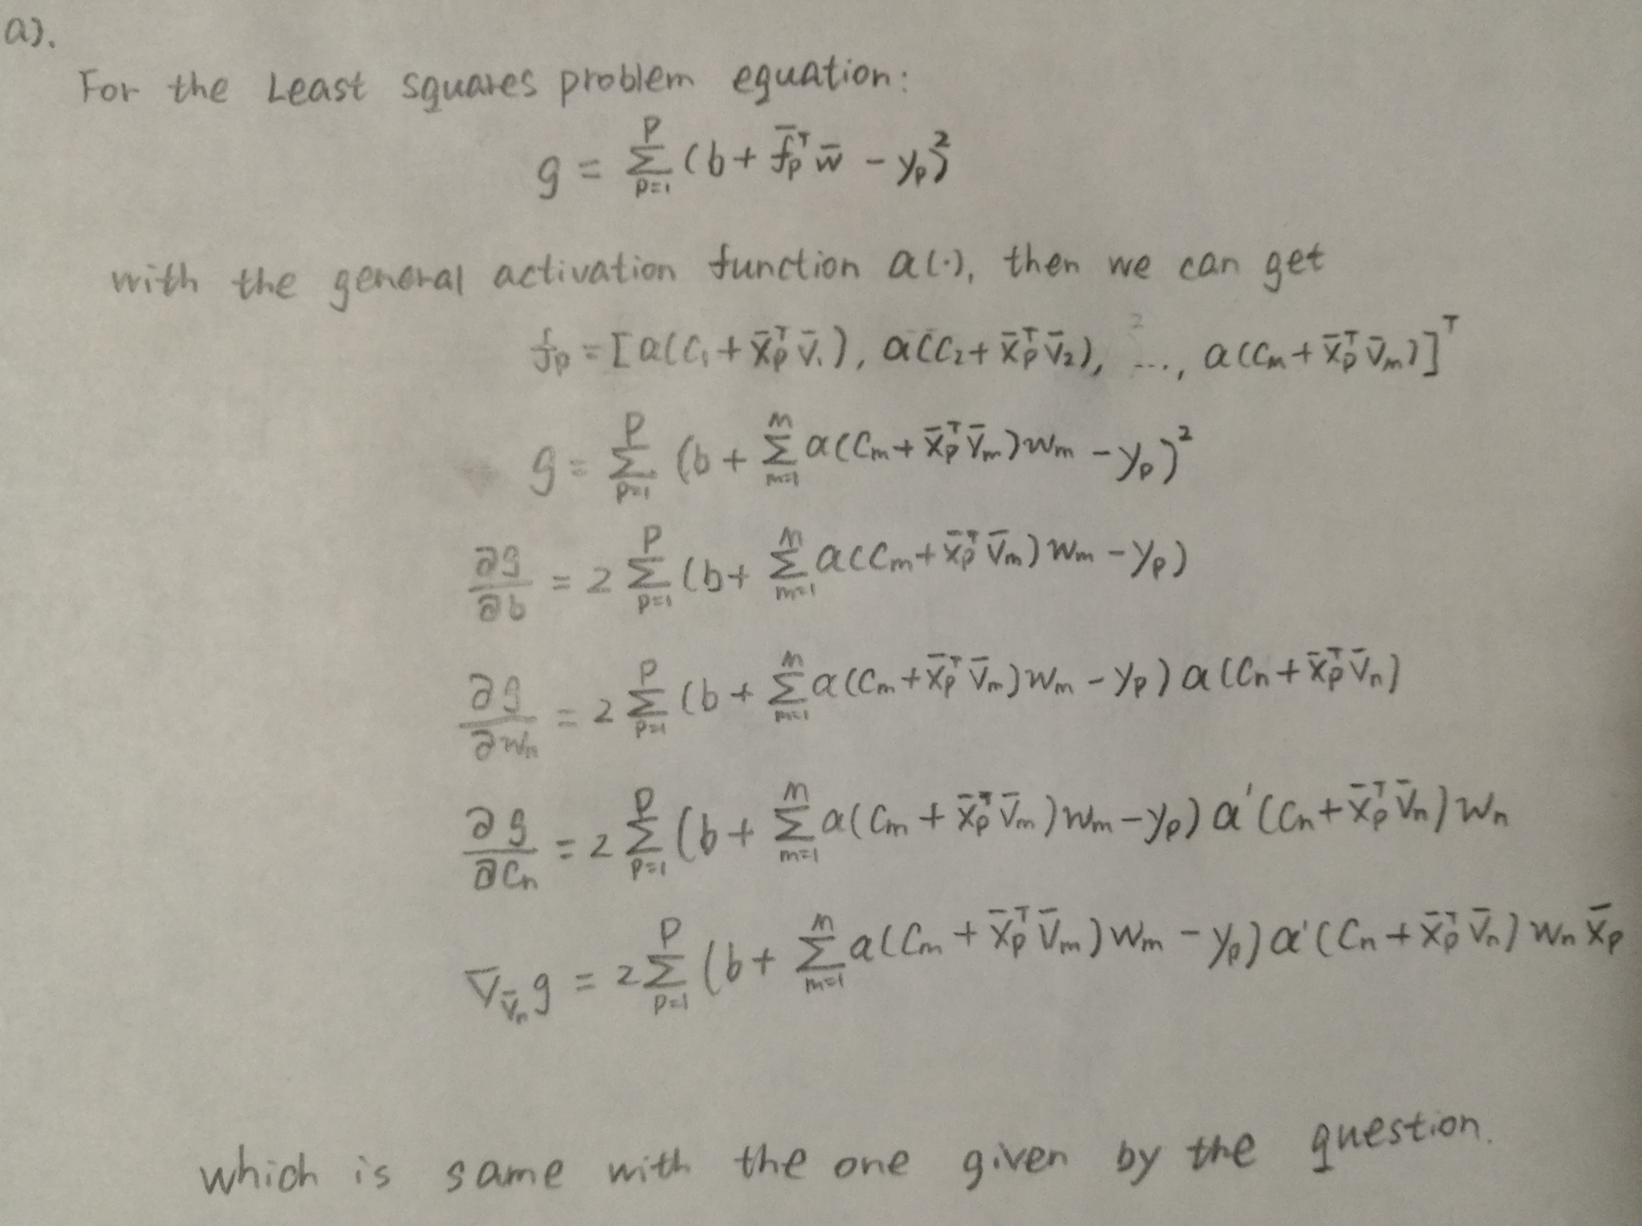

**(b)**

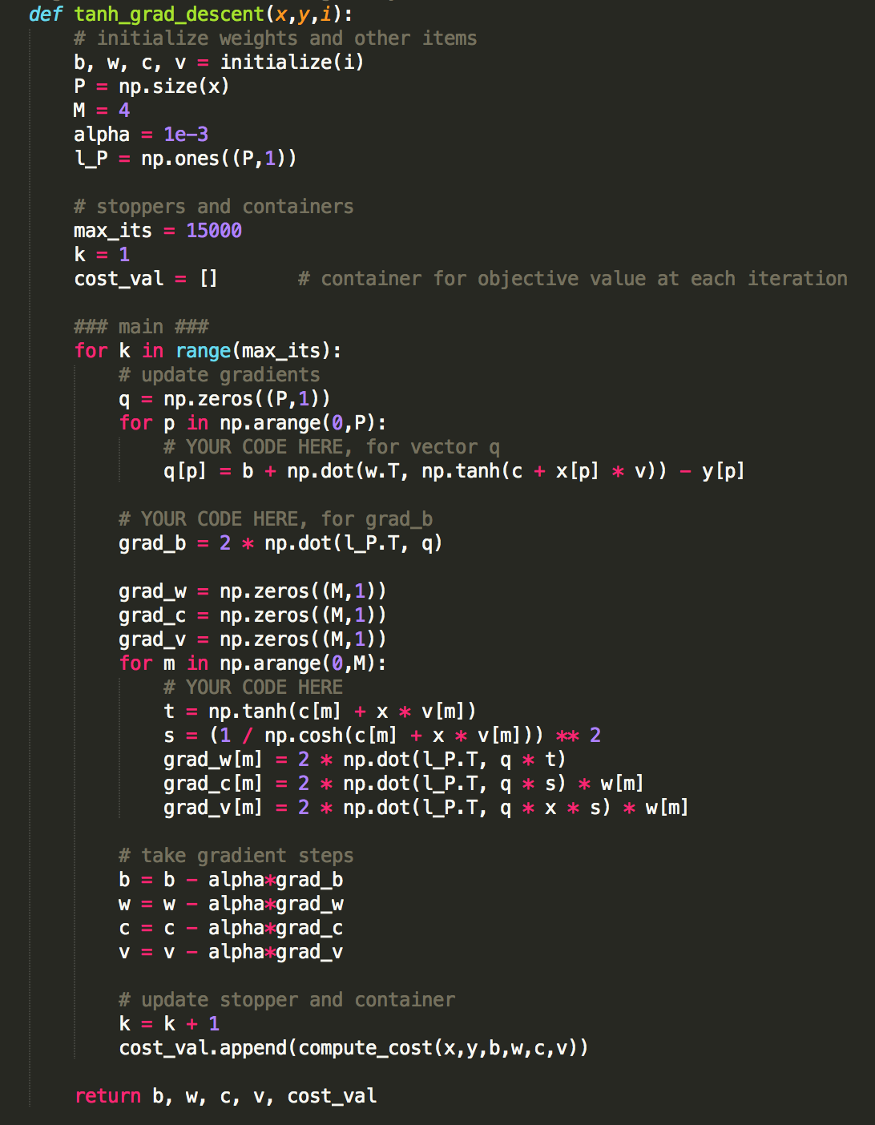

**(c)**

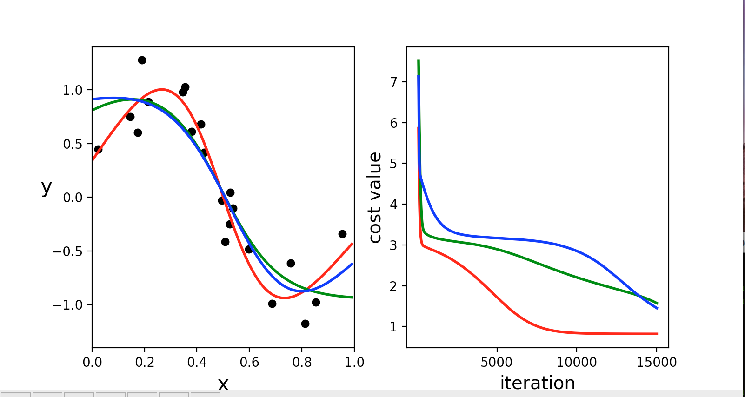

From the figure, we can see that when we increase the iteration, the result will become much more precise, and the cost value will be smaller and smaller. For different initialization, the function will be a little bit different, so does cost value.